ECEN 454 - Lab Report

Lab Number: 3
Lab Title: Cell Characterization using Spectre
Section Number: 341
Student’s Name: Abhishek Bhattacharyya
Student’s UIN: 731002289
Date: 9/25/2024

TA: Nishank Bansal

Inverter

Transient Analysis Waveform
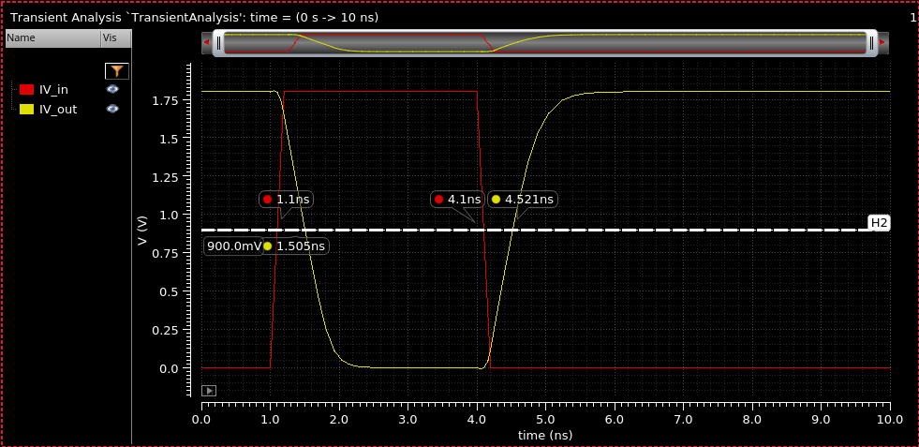

Parameters Used: wp = 1.1u, wn = 0.4u

Falling Delay: 1.505 - 1.1 = 0.405 ns

Rising Delay: 4.521 - 4.1 = 0.421 ns

Error Percentage: (Abs(Rising - Falling) / Min) * 100 = 3.95% < 10% ✅

Delay Table
Capacitance (fF) | Falling Delay (ns) | Rising Delay (ns) | Error Percentage (green for <10%)
1 | 0.02664 | 0.04348 | 63.21%
8 | 0.06883 | 0.08367 | 21.56%
15 | 0.09868 | 0.11105 | 12.54%
22 | 0.12401 | 0.13635 | 9.95%
29 | 0.14936 | 0.16137 | 8.04%
36 | 0.17476 | 0.18683 | 6.91%
43 | 0.20001 | 0.21269 | 6.34%
50 | 0.22496 | 0.23734 | 5.50%
57 | 0.22496 | 0.23734 | 5.50%
64 | 0.24993 | 0.26438 | 5.78%
71 | 0.27545 | 0.29086 | 5.59%
78 | 0.32581 | 0.34258 | 5.15%
85 | 0.35251 | 0.36 | 2.12%
92 | 0.37763 | 0.39347 | 4.19%
100 | 0.4014 | 0.42049 | 4.76%
wn = 0.4 |  | wp = 1.1

AC Sim Waveform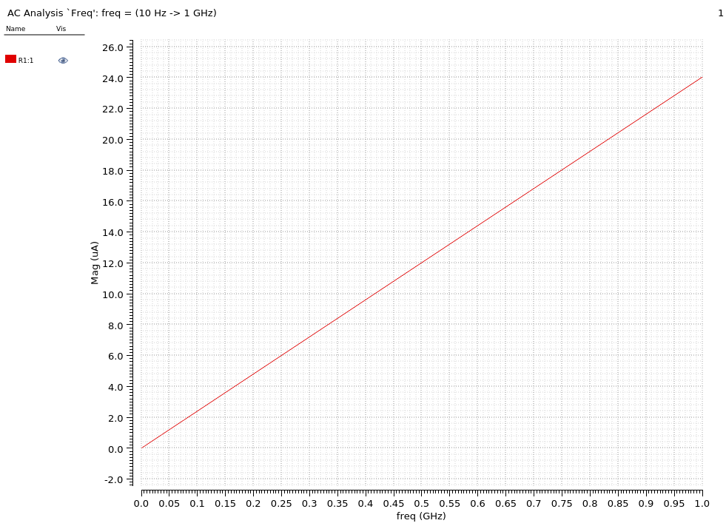

Sink Capacitance
Frequency (f) | Current (I) | Sink Capacitance
150 | 3.70E-12 | 3.92E-15
1.80E+08 | 4.32E-06 | 3.83E-15
3.04E+08 | 7.31E-06 | 3.83E-15
3.92E+08 | 9.42E-06 | 3.83E-15
4.81E+08 | 1.16E-05 | 3.84E-15
5.75E+08 | 1.38E-05 | 3.82E-15
6.79E+08 | 1.63E-05 | 3.82E-15
7.94E+08 | 1.91E-05 | 3.83E-15
9.17E+08 | 2.21E-05 | 3.84E-15
1.00E+09 | 2.40E-05 | 3.82E-15
 | Avg | 3.84E-15
Therefore, mean sink capacitance is 3.84 femtofarad.

NAND

Transient Analysis Waveform
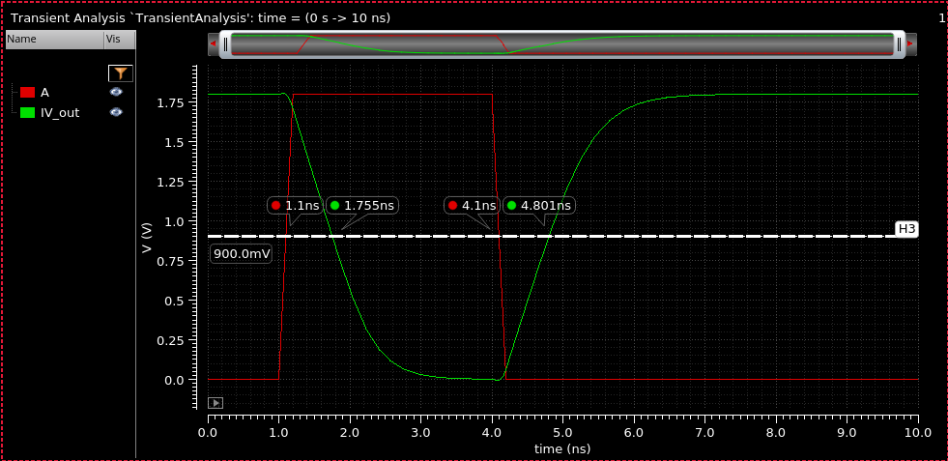

Parameters Used: wp = 0.6u, wn = 0.3u

Rising Delay: 1.755 - 1.1 = 0.655 ns

Falling Delay: 4.801 - 4.1 = 0.701 ns

Error Percentage: (Abs(Rising - Falling) / Min) * 100 = 7.02% < 10% ✅

Delay Table
Capacitance (fF) | out1 | out2 | Falling Delay (ns) | Rising Delay (ns) | Error Percentage (green for <10%)
1 | 1.136 | 4.158 | 0.036 | 0.058 | 61.11%
8 | 1.194 | 4.213 | 0.094 | 0.113 | 20.21%
15 | 1.237 | 4.257 | 0.137 | 0.157 | 14.60%
22 | 1.28 | 4.303 | 0.18 | 0.203 | 12.78%
29 | 1.322 | 4.347 | 0.222 | 0.247 | 11.26%
36 | 1.366 | 4.394 | 0.266 | 0.294 | 10.53%
43 | 1.408 | 4.439 | 0.308 | 0.339 | 10.06%
50 | 1.451 | 4.482 | 0.351 | 0.382 | 8.83%
57 | 1.496 | 4.527 | 0.396 | 0.427 | 7.83%
64 | 1.537 | 4.573 | 0.437 | 0.473 | 8.24%
71 | 1.579 | 4.619 | 0.479 | 0.519 | 8.35%
78 | 1.621 | 4.661 | 0.521 | 0.561 | 7.68%
85 | 1.664 | 4.706 | 0.564 | 0.606 | 7.45%
92 | 1.707 | 4.749 | 0.607 | 0.649 | 6.92%
99 | 1.749 | 4.795 | 0.649 | 0.695 | 7.09%
w_n = 0.3 |  |  |  | w_p = 0.6

Waveform

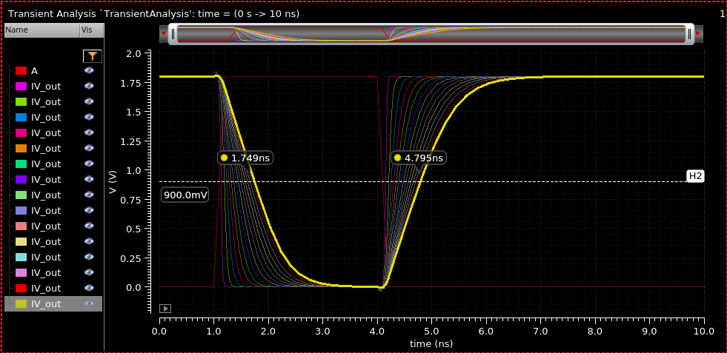

AC Sim Waveform
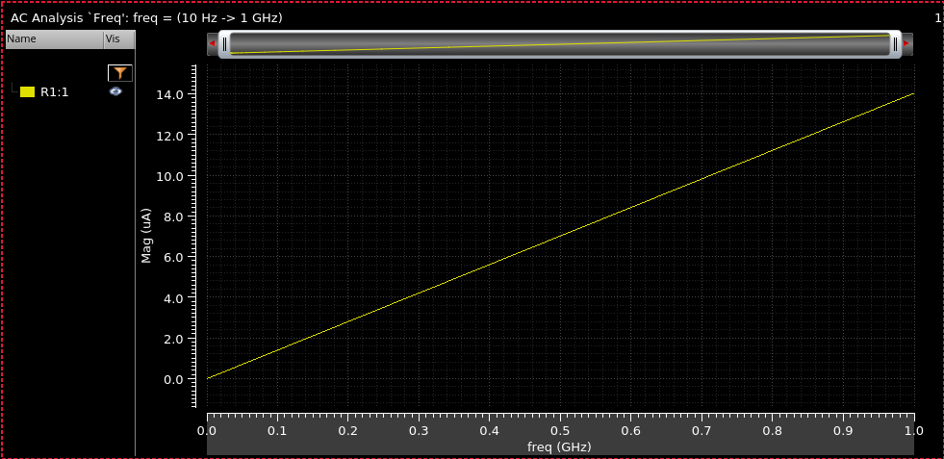

Sink Capacitance
Frequency (f) | Current (I) | Sink Capacitance
1.00E+08 | 1.41E-06 | 2.24E-15
2.00E+08 | 2.81E-06 | 2.24E-15
3.00E+08 | 4.21E-06 | 2.23E-15
4.00E+08 | 5.62E-06 | 2.24E-15
5.00E+08 | 7.02E-06 | 2.23E-15
6.00E+08 | 8.43E-06 | 2.24E-15
7.00E+08 | 9.83E-06 | 2.24E-15
8.00E+08 | 1.12E-05 | 2.24E-15
9.00E+08 | 1.26E-05 | 2.23E-15
1.00E+09 | 1.40E-05 | 2.24E-15
 | Avg | 2.23E-15

XOR

Transient Analysis Waveform
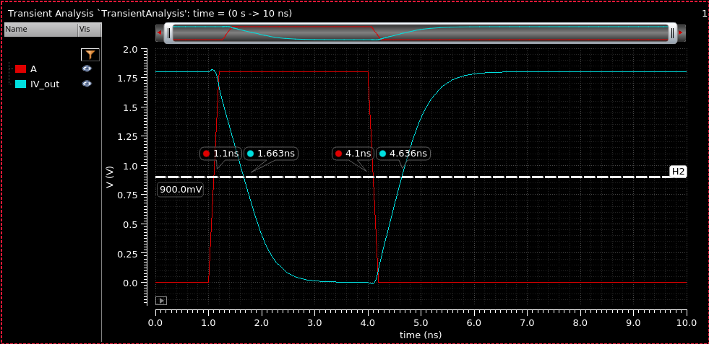

Parameters Used: wp = 1.6u, wn = 0.4u

Rising Delay: 1.663 - 1.1 = 0.563 ns

Falling Delay: 4.636 - 4.1 = 0.536 ns

Error Percentage: (Abs(Rising - Falling) / Min) * 100 = 5.04% < 10% ✅

Delay Table
Capacitance (fF) | out1 | out2 | Falling Delay (ns) | Rising Delay (ns) | Error Percentage (green for <10%)
1 | 1.146 | 4.152 | 0.046 | 0.052 | 13.04%
8 | 1.188 | 4.193 | 0.088 | 0.093 | 5.68%
15 | 1.222 | 4.224 | 0.122 | 0.124 | 1.64%
22 | 1.259 | 4.258 | 0.159 | 0.158 | 0.63%
29 | 1.296 | 4.292 | 0.196 | 0.192 | 2.08%
36 | 1.333 | 4.326 | 0.233 | 0.226 | 3.10%
43 | 1.369 | 4.361 | 0.269 | 0.261 | 3.07%
50 | 1.406 | 4.395 | 0.306 | 0.295 | 3.73%
57 | 1.442 | 4.43 | 0.342 | 0.33 | 3.64%
64 | 1.478 | 4.462 | 0.378 | 0.362 | 4.42%
71 | 1.514 | 4.496 | 0.414 | 0.396 | 4.55%
78 | 1.551 | 4.532 | 0.451 | 0.432 | 4.40%
85 | 1.586 | 4.565 | 0.486 | 0.465 | 4.52%
92 | 1.622 | 4.598 | 0.522 | 0.498 | 4.82%
99 | 1.658 | 4.632 | 0.558 | 0.532 | 4.89%
w_n = 0.4 |  |  |  | w_p = 1.6

Waveform

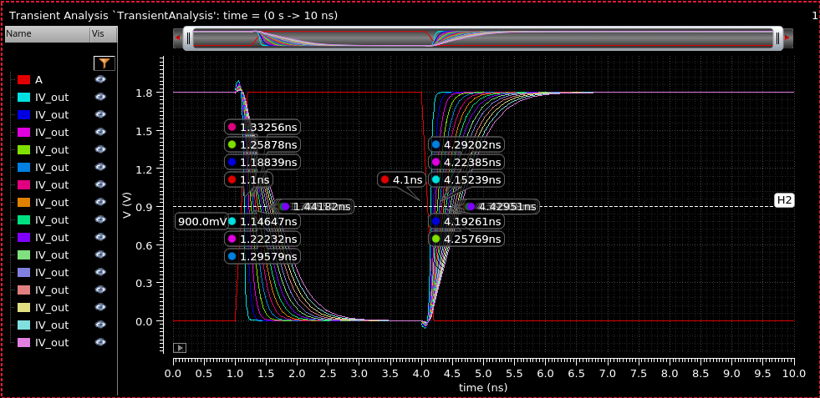

AC Sim Waveform
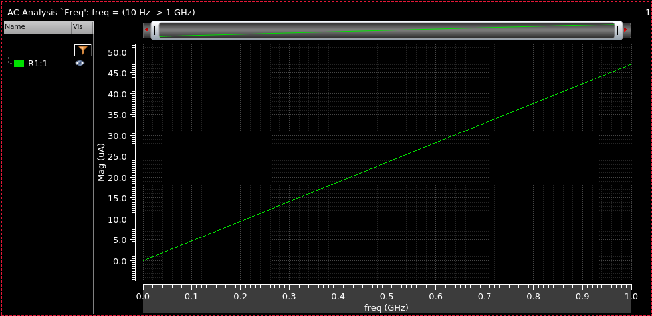

Sink Capacitance
Frequency (f) | Current (I) | Sink Capacitance
1.00E+08 | 4.72E-06 | 7.51E-15
2.00E+08 | 9.44E-06 | 7.51E-15
3.00E+08 | 1.42E-05 | 7.51E-15
4.00E+08 | 1.89E-05 | 7.51E-15
5.00E+08 | 2.36E-05 | 7.51E-15
6.00E+08 | 2.83E-05 | 7.50E-15
7.00E+08 | 3.30E-05 | 7.50E-15
8.00E+08 | 3.77E-05 | 7.50E-15
9.00E+08 | 4.24E-05 | 7.49E-15
1.00E+09 | 4.71E-05 | 7.49E-15
 | Avg | 7.51E-15

Summary of Parameters
 | W_{P} | W_{N}
Inverter | 1.1u | 0.4u
NAND | 0.6u | 0.3u
XOR | 1.6u | 0.4u

Files

Cell18.spi
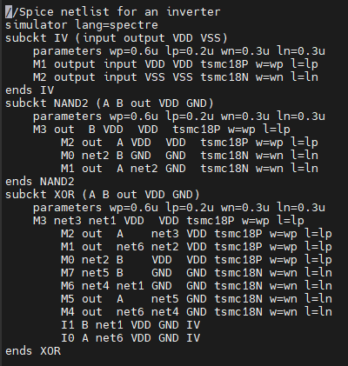

inverter.spi
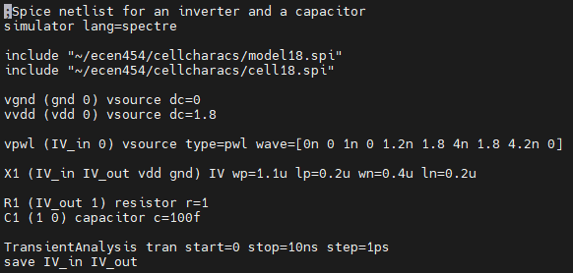

Nand2.spi
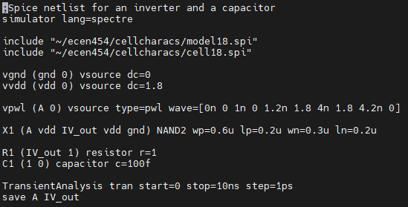

Xor.spi
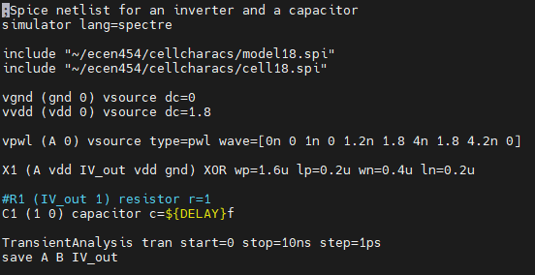

simcap_inverter.spi
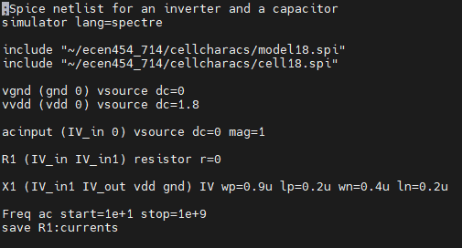

simcap_nand2.spi
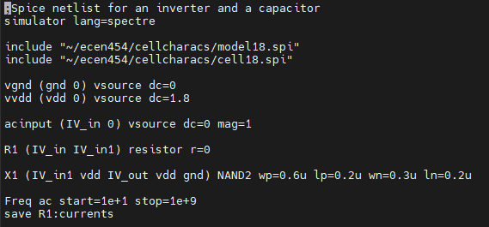

simcap_xor.spi
